To perform an Unbind from P2P Account you will need:

-Access to the NVR/DVR GUI via Display and Mouse

-Admin credentials to log into the NVR/DVR

-Mobile Phone with App

-Connection to same Wifi Network as the NVR/DVR

1. Make sure to download the Mobile App.

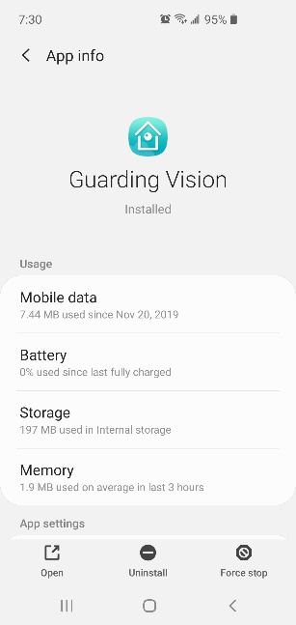 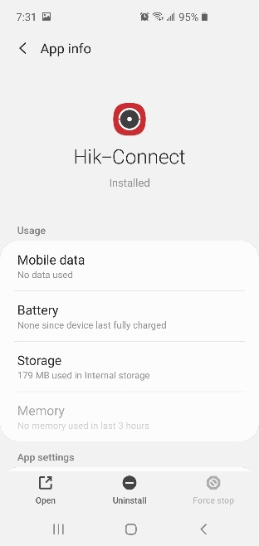

1. Make sure you are logged into a P2P Account you want to add device too. (This can be created for free at [www.guardingvision.com](http://www.guardingvision.com) or [www.hik-connect.com](http://www.hik-connect.com).

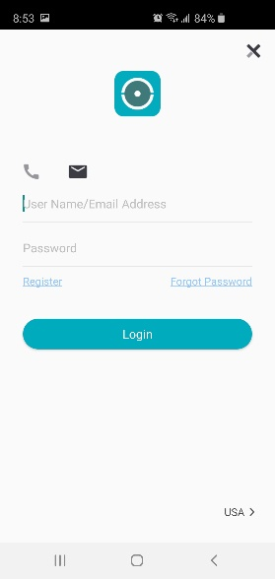

1. Navigate on the NVR/DVR GUI to the Platform Access Screen, this can be different between V3.x and V4.x NVR/DVR Firmware.

**V3.x**

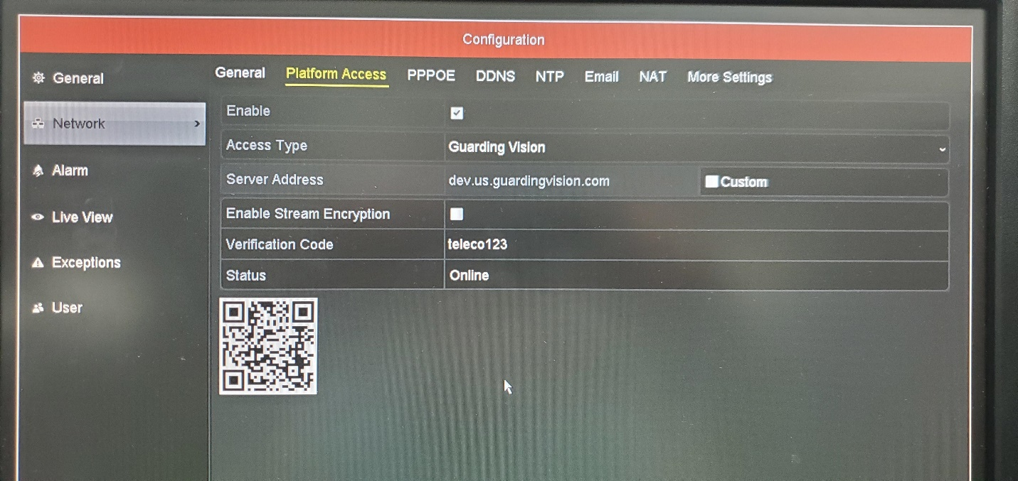

**V4.x**

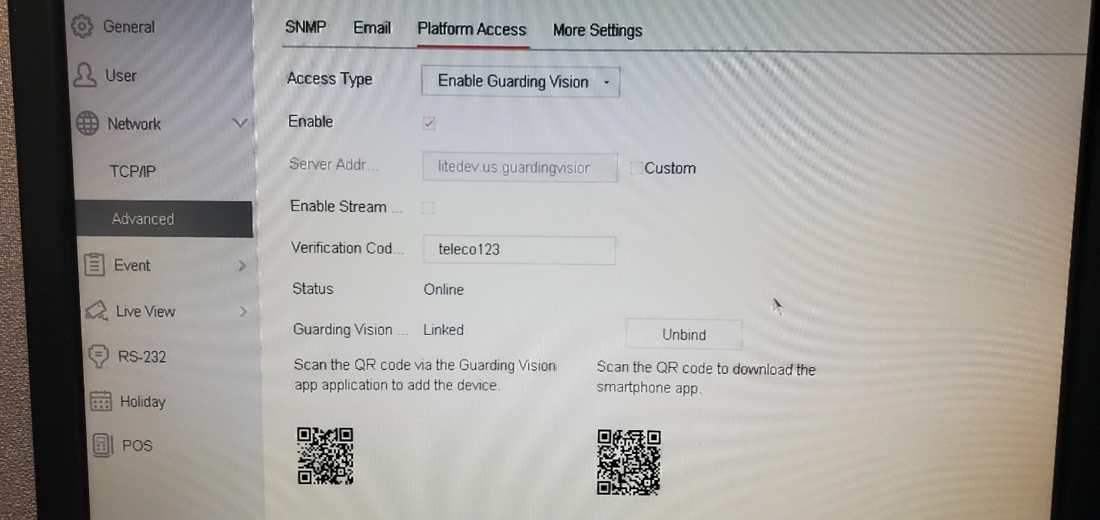

1. From the App Home Page, select the “+” in the top right and select Scan.

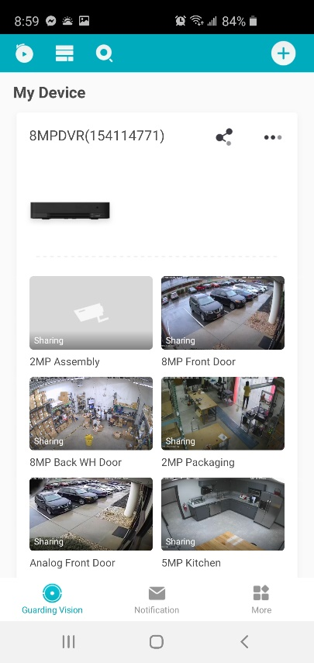

1. Select the “Unbind” Option

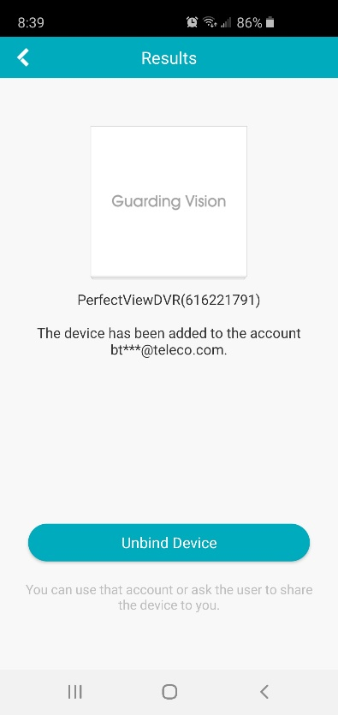

1. Enter in admin password of NVR/DVR, CAPTCHA, and hit “Finish”

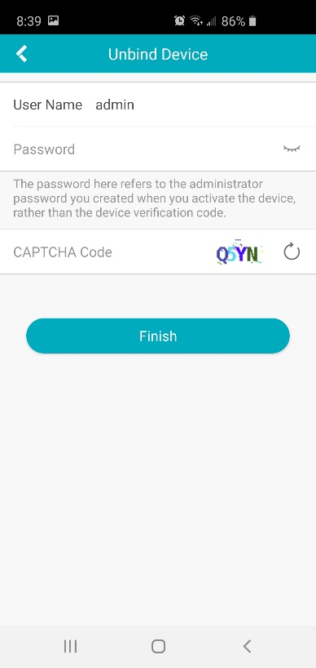

1. Device is now Unbound from original account and can be added to new account. Perform STEP FOUR again to add to account you are logged into.

